CNT3004: Computer Network Concepts
Homework 5&6

(100 pts total) Answer each of the following questions and/or complete the required task. You will be installing some software on your system, but it is safe. Put ALL your answers into 1 file (word, or pdf).

- (20 pts) Identify and define the following 5 security certifications (you will need to use the Internet):
CERTIFICATION | WHAT IT STANDS FOR | BRIEF DESCRIPTION | WHO DEVELOPED AND/OR MANAGES THE CERTIFICATION
CEH | Certified Ethical Hacker | Ethical hacking, teaching how to identify and test for vulnerabilities by understanding the mindset of a malicious hacker | EC - Council
CISM | Certified Information Security Manager | Emphasizes information security governance, risk management and incident response targeting security managers and professionals | ISACA
SECURITY+ | Security+ | Entry-level cert covering foundational cybersecurity skills like threat management, risk mitigation and securing systems | CompTIA
CISSP | Certified Information Systems Security Professional | Advanced cert covering a broad range of security topics such as risk management, security architecture and operations | (ISC)^2
CISA | Certified Information Systems Auditor | Focuses on auditing, control and assurance for information systems, ensuring integrity, confidentiality and reliability | ISACA

- (20 pts) List and define the following 5 Network Risk Management Software Products (use the Internet to find answers):
RISK MANAGEMENT SOFTWARE | BRIEF DESCRIPTION (WHAT IT DOES/HOW IT WORKS) | WHO DEVELOPED AND/OR MANAGES THE SOFTWARE
LogicGate Risk Cloud | Platform for managing risk, compliance and governance. Provides workflow automation and customizable frameworks. | LogicGate
SecurityScorecard | Offers cybersecurity risk ratings and continuous monitoring of third-party risk based on automated security threats. | SecurityScaorecard
Fastpath Assure | Focuses on managing user access, segregation of duties, and audit compliance for enterprise systems. | Fastpath Solutions, LLC
SAI360 | An integrated risk management platform covering compliance, risk, audits, and ethics programs, with data driven insights. | SAI Global
SureCloud | Provides a suite of tools for governance, risk and compliance including risk assessments and regulatory compliance | SureCloud

- (20 pts) Identify the following 5 WAN technologies.
WAN TECHNOLOGY | DESCRIPTION | HOW IS IT USED
ATM | Asynchronous Transfer Mode is a cell based switching and multiplexing technology that transmits fixed length cells to ensure predictable performance. | Commonly used for real time applications like video conferences and voice, as well as backbone networks.
FRAME RELAY | A packet switched technology that uses virtual circuits to transmit variable sized frames. | Used for connecting LAN networks over WANs, typically for enterprise communication.
SONET | Synchronous Optical Network us a fiber optic transmission standard for high speed data transfer. | Used in telecommunications for high capacity, long distance data transfer and to connect large networks.
MPLS | Multiprotocol Label Switching directs data using short labels rather than complex network addresses. | Used to prioritize traffic and support QoS for voice, video and data across enterprise networks.
SATELLITE | Uses communication satellites to provide connectivity over long distances and remote areas. | Used in remote locations where other WAN technologies are unavailable, such as rural areas or maritime environments.

- (40 pts) You will be running programs on your Windows Machine (if you have a Mac you will need to dual boot Windows on your machine if you have not done so already or use the MAC tools that are similar, go to https://support.apple.com/guide/activity-monitor/welcome/mac).
  - Type MMC in the search field (left bottom of screen).
  - The Microsoft Management Counsel will appear named Console1 in the upper left of the window.
  - Click on File and then Add/Remove Snap In.
  - Add the following Snap-in(s)
    - Device Manager
    - Event Viewer (for the local computer)
    - Services (for the local computer)
  - Then click on OK. All three tools will be showing. Take a screen shot showing that they are all in the MMC.
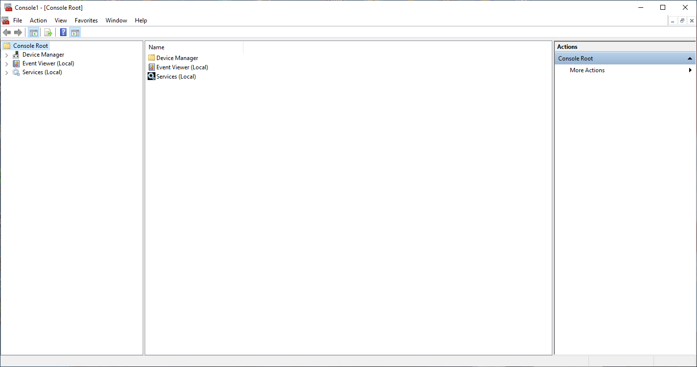
  - Next, click on Device Manager and a list of devices will show. Take a screen shot of this.
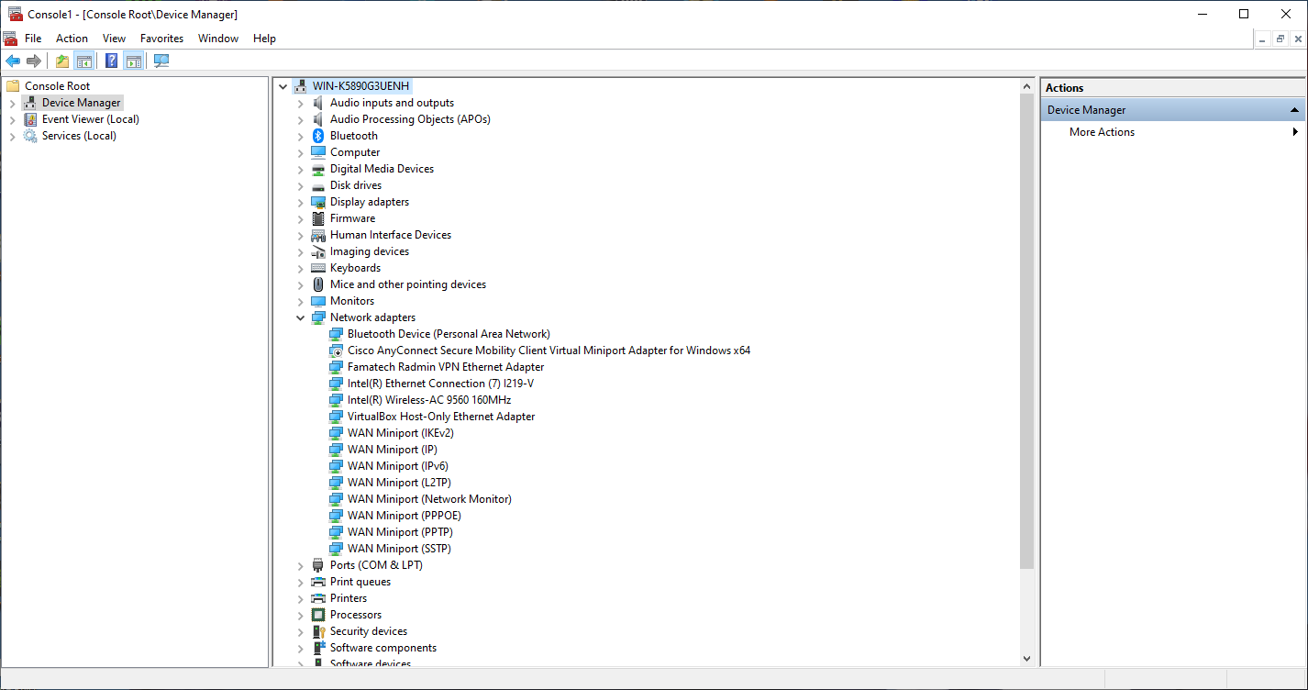
    - Click on Computer icon and then the computer name listed. You should get another window with the tabs: General, Driver, Details and Events. Take a screen shot of this.
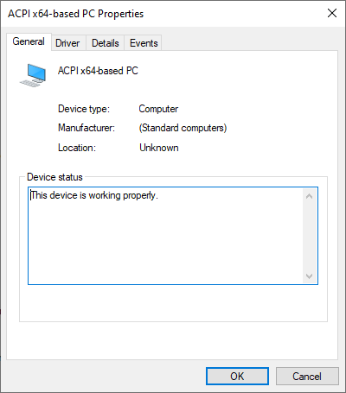
  - Next, click on Event Viewer (Local) – you should see an Overview and Summary window (take a screen shot of this).
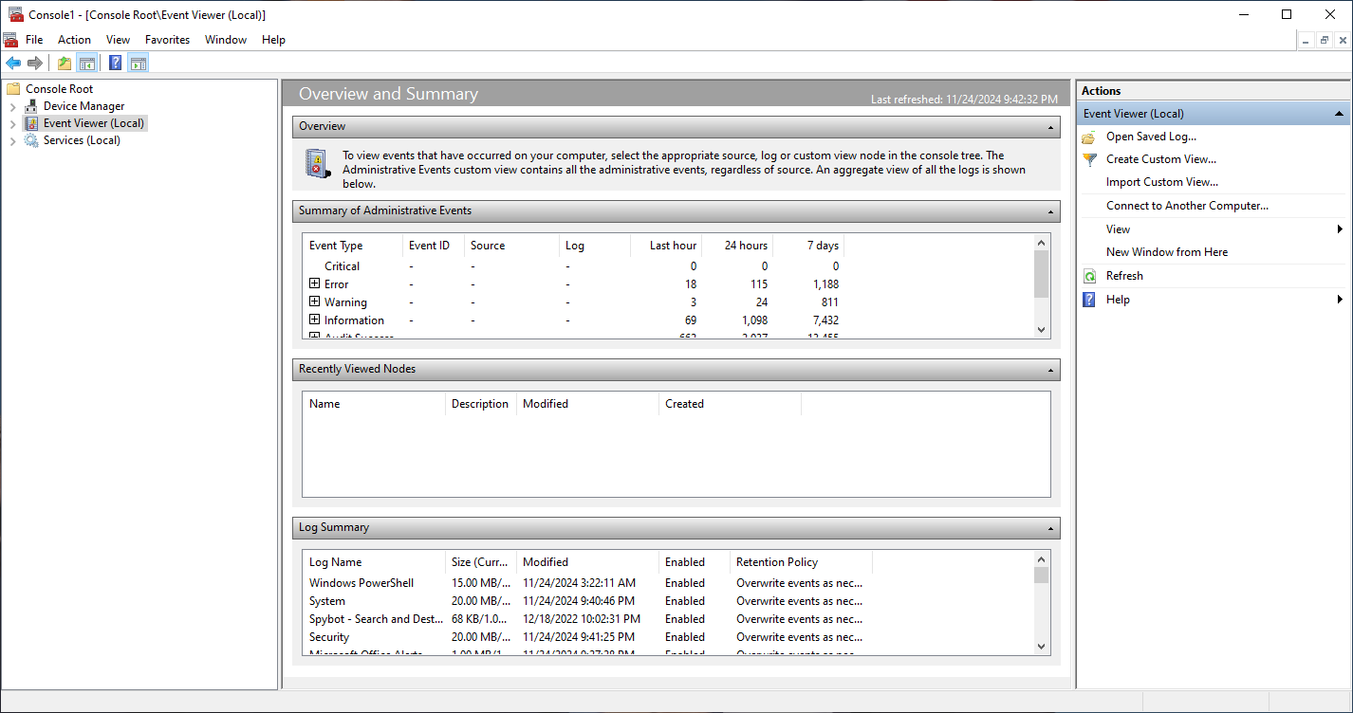
    - Click on the System log in the Windows Logs folder. There are Levels of errors. What are they? Information, Warning, Error
    - Click on one of the items in the System Log file and take a screen shot (it should open a new window with the General and Details tab.
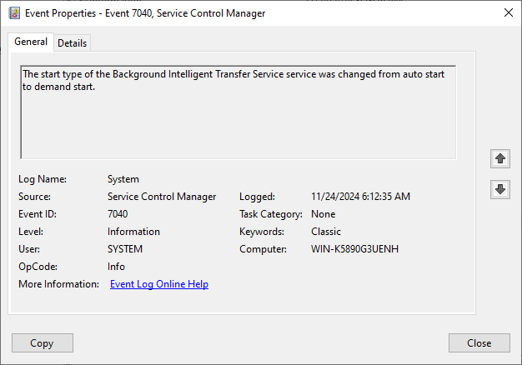
  - Lastly, click on Services (Local) and take a screen shot of the window (should show the Name of the services on your system). You can click on ANY of the services to get a more detailed explanation. Click on one of these processes and take a screen shot.
